yum -y install epel-release perl pcre-devel openssl-devel gcc curl unzip wget zip

useradd www

cd /home && wget https://mirror.cnop.net/web/openresty/openresty-1.19.9.1.tar.gz
tar zxvf openresty-1.19.9.1.tar.gz && cd openresty-1.19.9.1

./configure --user=www --group=www --prefix=/usr/local/openresty --with-pcre --with-stream --with-threads --with-file-aio --with-http_v2_module --with-http_ssl_module --with-http_realip_module --with-http_gzip_static_module --with-http_stub_status_module

make && sudo make install

cp /usr/local/openresty/bin/openresty /usr/local/bin/nginx && chmod +x /usr/local/bin/nginx && cp /usr/local/openresty/bin/openresty /usr/sbin/nginx && chmod +x /usr/sbin/nginx

ln -sf /usr/local/openresty/nginx/sbin/nginx /usr/local/bin/nginx
ln -sf /usr/local/openresty/nginx/sbin/nginx /usr/sbin/nginx

cd /etc/init.d
wget https://mirror.cnop.net/web/openresty/openresty && mv openresty nginx
vi nginx #以下内容请根据自己的安装路径来

#!/bin/bash
# nginx Startup script for the Nginx HTTP Server
# chkconfig: - 85 15
# description: Nginx is a high-performance web and proxy server.
# It has a lot of features, but it's not for everyone.
# processname: nginx
# pidfile: /usr/local/openresty/nginx/logs/nginx.pid
# config: /usr/local/openresty/nginx/conf/nginx.conf

#nginx path
nginxd=/usr/local/openresty/bin/openresty
nginx_config=/usr/local/openresty/nginx/conf/nginx.conf
nginx_pid=/usr/local/openresty/nginx/logs/nginx.pid
RETVAL=0
prog="nginx"
# Source function library.
. /etc/rc.d/init.d/functions
# Source networking configuration.
. /etc/sysconfig/network
# Check that networking is up.
[ ${NETWORKING} = "no" ] && exit 0
[ -x $nginxd ] || exit 0
# Start nginx daemons functions.
start() {
if [ -e $nginx_pid ];then
echo "nginx already running...."
exit 1
fi
echo -n $"Starting $prog: "
daemon $nginxd -c ${nginx_config}
RETVAL=$?
echo
[ $RETVAL = 0 ] && touch /var/lock/subsys/nginx
return $RETVAL
}
# Stop nginx daemons functions.
stop() {
echo -n $"Stopping $prog: "
killproc $nginxd
RETVAL=$?
echo
[ $RETVAL = 0 ] && rm -f /var/lock/subsys/nginx /usr/local/openresty/nginx/logs/nginx.pid
}
# reload nginx service functions.
reload() {
echo -n $"Reloading $prog: "
#kill -HUP `cat ${nginx_pid}`
killproc $nginxd -HUP
RETVAL=$?
echo
}
# See how we were called.
case "$1" in
start)
start
;;
stop)
stop
;;
reload)
reload
;;
restart)
stop
start
;;
status)
status $prog
RETVAL=$?
;;
*)
echo $"Usage: $prog {start|stop|restart|reload|status|help}"
exit 1
esac
exit $RETVAL

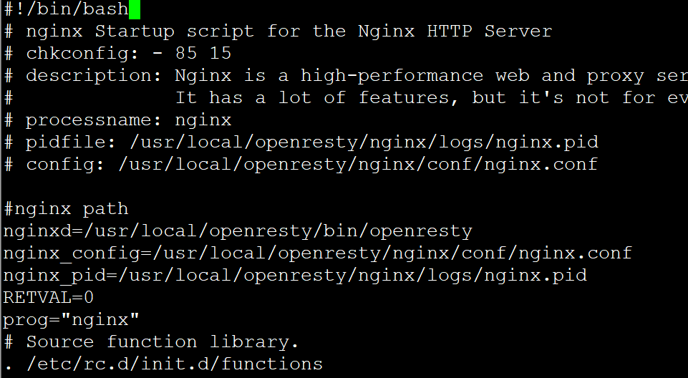

chmod +x nginx
chmod +x /etc/rc.d/rc.local
chkconfig --add nginx && systemctl daemon-reload && /sbin/chkconfig nginx on && systemctl start nginx.service

Openresty实现WAF防火墙功能

yum install -y gcc-c++ libtool gmake make pcre pcre-devel openssl openssl-devel zlib zlib-devel readline readline-devel

本步骤可省略：
vi /usr/local/openresty/nginx/conf/nginx.conf
server中加入以下：

location /hello {
default_type text/html;
content_by_lua_block {
ngx.say("HelloWorld")
}
}

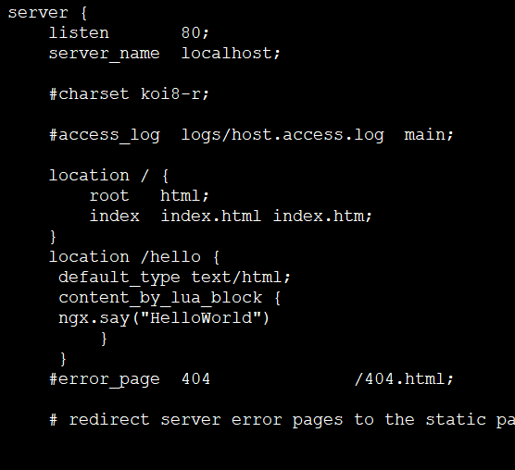

service nginx reload

访问以下链接可测试lua：
http://ip/hello

################################################################################################

WAF的功能
- 支持IP白名单和黑名单功能，直接将黑名单的IP访问拒绝。
- 支持URL白名单，将不需要过滤的URL进行定义。
- 支持User-Agent的过滤，匹配自定义规则中的条目，然后进行处理（返回403）。
- 支持CC攻击防护，单个URL指定时间的访问次数，超过设定值，直接返回403。
- 支持Cookie过滤，匹配自定义规则中的条目，然后进行处理（返回403）。
- 支持URL过滤，匹配自定义规则中的条目，如果用户请求的URL包含这些，返回403。
- 支持URL参数过滤，原理同上。
- 支持日志记录，将所有拒绝的操作，记录到日志中去。
- 日志记录为JSON格式，便于日志分析，例如使用ELKStack进行攻击日志收集、存储、搜索和展示。

部署WAF:WAF已经有人通过lua写出了这个开源的功能，在此直接拿来用即可。GitHub地址：https://github.com/unixhot/waf
下载waf模块：
git clone https://github.com/unixhot/waf.git
或
wget https://mirror.cnop.net/web/module/waf-1.0.1.tar.gz && tar zxvf waf-1.0.1.tar.gz
cd waf-1.0.1 && cp -r waf /usr/local/openresty/nginx/conf
ln -s /usr/local/openresty/lualib/resty/ /usr/local/openresty/nginx/conf/waf/resty
ls -lrth /usr/local/openresty/nginx/conf/waf/

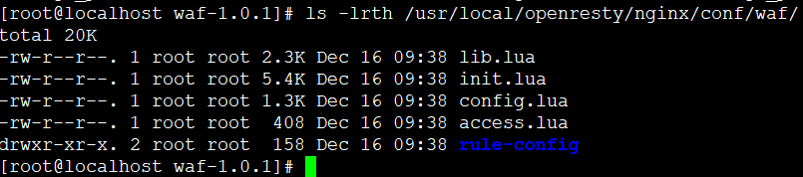
以上access.lua、lib.lua、init.lua都是功能实现的lua代码，如果不具备lua的开发能力，我们一般不会去进行改动
config.lua为各个功能的配置文件
rule-config目录存放了各种防御策略规则
我们需要经常改动config.lua和存储策略的文件

ls /usr/local/openresty/nginx/conf/waf/rule-config/ -rlth
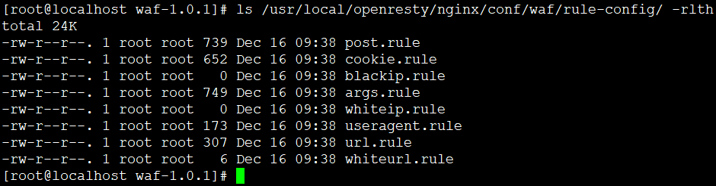
#Cookie策略文件
#异常Get参数策略文件
#白名单URL策略文件
#IP白名单策略文件
#异常UserAgent策略文件
#异常URL策略文件
#异常POST参数策略文件
#IP黑名单策略文件

Openresty引入WAF模块
1.修改nginx配置来引入WAF模块
如下在Nginx中加入以下配置来引入WAF模块
lua-resty-core 模块：
cd /usr/local/openresty/

git clone https://github.com/openresty/lua-resty-core.git
或
wget https://mirror.cnop.net/web/module/lua-resty-core.tar.gz && tar zxvf lua-resty-core.tar.gz
vi /usr/local/openresty/nginx/conf/nginx.conf
http中加入

lua_shared_dict limit 50m;
lua_package_path "/usr/local/openresty/nginx/conf/waf/?.lua";
init_by_lua_file "/usr/local/openresty/nginx/conf/waf/init.lua";
access_by_lua_file "/usr/local/openresty/nginx/conf/waf/access.lua";

参考 https://github.com/unixhot/waf

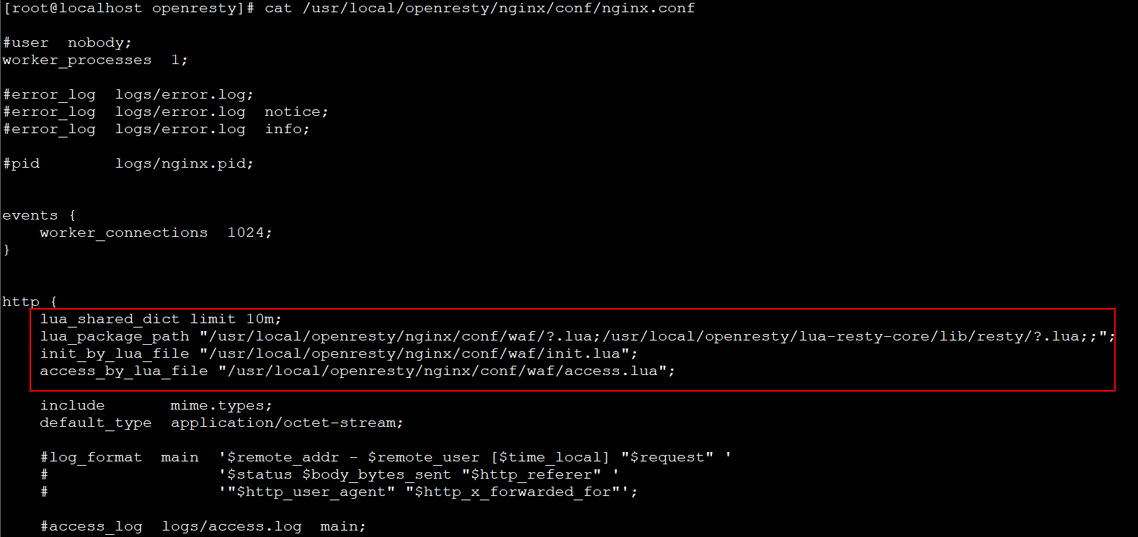

chown -R www.www /usr/local/openresty/nginx

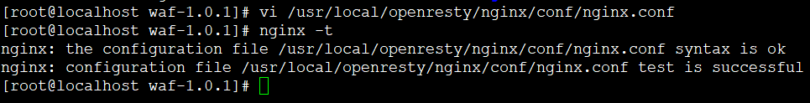

nginx -t #保存后测试配置有没错误
service nginx reload

###### 以下是配置内容，可根据情况自行更改 #####

cat /usr/local/openresty/nginx/conf/waf/config.lua #此为配置文件,可以在里面配置以下内容

config_waf_enable = "on" --是否启用waf模块，值为 on 或 off
config_log_dir = "/usr/local/openresty/nginx/logs" --waf的日志位置，日志格式默认为json,此文件位置可自行更改，默认/tmp文件夹
config_rule_dir = "/usr/local/openresty/nginx/conf/waf/rule-config" --策略规则目录位置，可根据情况变动
config_white_url_check = "on" --是否开启URL检测
config_white_ip_check = "on" --是否开启IP白名单检测
config_black_ip_check = "on" --是否开启IP黑名单检测
config_url_check = "on" --是否开启URL过滤
config_url_args_check = "on" --是否开启Get参数过滤
config_user_agent_check = "on" --是否开启UserAgent客户端过滤
config_cookie_check = "on" --是否开启cookie过滤
config_cc_check = "on" --是否开启cc攻击过滤
config_cc_rate = "20/60" --cc攻击的速率/时间；默认单个IP60秒内访问同一个页面超过10次则认为是cc攻击，则自动禁止此IP地址访问此页面60秒(封禁过程中此IP地址依然可以访问其它页面，如果同一个页面访问次数超过10次依然会被禁止)
config_post_check = "on" --是否开启POST检测
config_waf_output = "html" --定义违反规则的请求跳转到一个自定义html页面（默认值为 html ），即下面的提示网页，也可以设置 “redirect” 值，跳转到其他指定网站页面。
config_waf_redirect_url = "https://www.unixhot.com" --指定违反请求后跳转到的其他网站页面的位置
--指定违反规则后跳转的自定义html页面，下面是内容：
config_output_html=[[
<html>
<head>
<meta http-equiv="Content-Type" content="text/html; charset=utf-8" />
<meta http-equiv="Content-Language" content="zh-cn" />
<title>网站防火墙</title>
</head>
<body>
<h1 align="center"> 欢迎白帽子进行授权安全测试，安全漏洞请联系QQ：xxxxxx
</body>
</html>
]]

http://192.168.50.245/s.sql #访问一个sql文件（这里以我的ip为例）

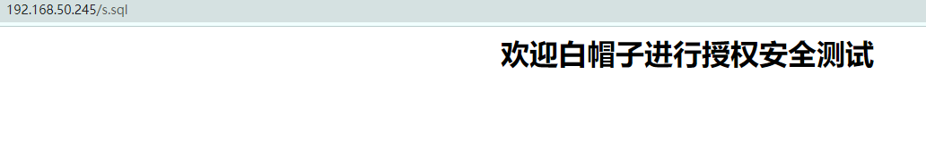
常用：
IP黑名单配置：需要在config.lua中开启config_black_ip_check = "on"参数
需开启config_black_ip_check = "on" ，ip加入以下文件，即可返回403被禁止（无需重启，直接生效，格式如下）：
cat /usr/local/openresty/nginx/conf/waf/rule-config/blackip.rule
192.168.31.14

IP白名单配置:需要在config.lua中开启config_white_ip_check = "on"参数
cat /usr/local/openresty/nginx/conf/waf/rule-config/whiteip.rule

CC攻击过滤：需要在config.lua中开启config_cc_check = "on"参数，然后指定config_cc_rate = "10/60"速率和时间（60秒自动解封，请根据情况自行选择）

异常URL策略配置：需在config.lua中开启config_url_check = "on"参数然后定义rule-config/url.rule文件，url.rule文件默认为如下，如果匹配到规则的将跳转到由config.lua中config_waf_output = "html"参数指定的页面
cat /usr/local/openresty/nginx/conf/waf/rule-config/url.rule
禁止URL访问包含以下内容的文件，当被访问时跳转到config.lua中指定的页面：

\.(htaccess|bash_history)
\.(bak|inc|old|mdb|sql|backup|java|class|tgz|gz|tar|zip)$
(phpmyadmin|jmx-console|admin-console|jmxinvokerservlet)
java\.lang
\.svn\/
/(attachments|upimg|images|css|uploadfiles|html|uploads|templets|static|template|data|inc|forumdata|upload|includes|cache|avatar)/(\\w+).(php|jsp)

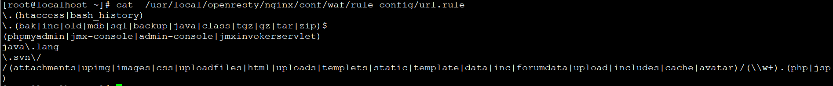
例，当访问 http://192.168.50.245/1.mdb 时，跳转到以下界面：
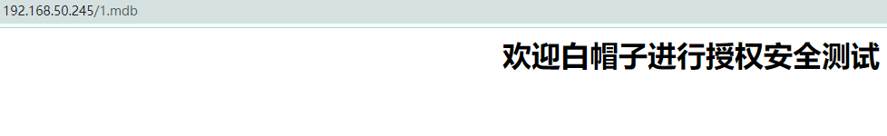
以上文件可根据情况自行增减。

异常UserAgent策略配置：需要在config.lua中开启config_user_agent_check = "on"参数
WAF模块中默认封锁了以下UserAgent，如HTTrack网站下载，namp网络扫描，audit网络审计，dirbuster网站目录扫描，pangolin SQL注入工具，scan网络扫描，hydra密码暴力破解，libwww漏洞工具，sqlmap自动SQL注入工具，w3af网络扫描，Nikto Web漏洞扫描等等。

cat /usr/local/openresty/nginx/conf/waf/rule-config/useragent.rule

我们正常访问URL是没问题的，下面来模拟一个非法的UserAgent进行访问.

模拟网站下载：
curl http://192.168.50.245 --user-agent "HTTrack"

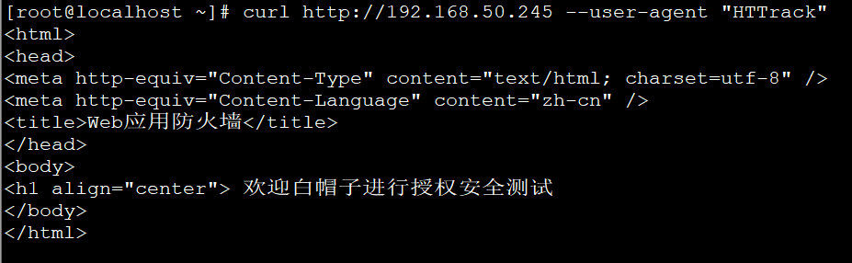

模拟nmap网络扫描: curl http://192.168.50.245 --user-agent "nmap"

异常Get参数策略配置:需要在config.lua配置中开启config_url_args_check = "on"参数
cat /usr/local/openresty/nginx/conf/waf/rule-config/args.rule
默认封锁了如下：
\.\./
\:\$
\$\{
select.+(from|limit)
(?:(union(.*?)select))
having|rongjitest
sleep\((\s*)(\d*)(\s*)\)
benchmark\((.*)\,(.*)\)
base64_decode\(
(?:from\W+information_schema\W)
(?:(?:current_)user|database|schema|connection_id)\s*\(
(?:etc\/\W*passwd)
into(\s+)+(?:dump|out)file\s*
group\s+by.+\(
xwork.MethodAccessor
(?:define|eval|file_get_contents|include|require|require_once|shell_exec|phpinfo|system|passthru|preg_\w+|execute|echo|print|print_r|var_dump|(fp)open|alert|showmodaldialog)\(
xwork\.MethodAccessor
(gopher|doc|php|glob|file|phar|zlib|ftp|ldap|dict|ogg|data)\:\/
java\.lang
\$_(GET|post|cookie|files|session|env|phplib|GLOBALS|SERVER)\[
\<(iframe|script|body|img|layer|div|meta|style|base|object|input)
(onmouseover|onerror|onload)\=

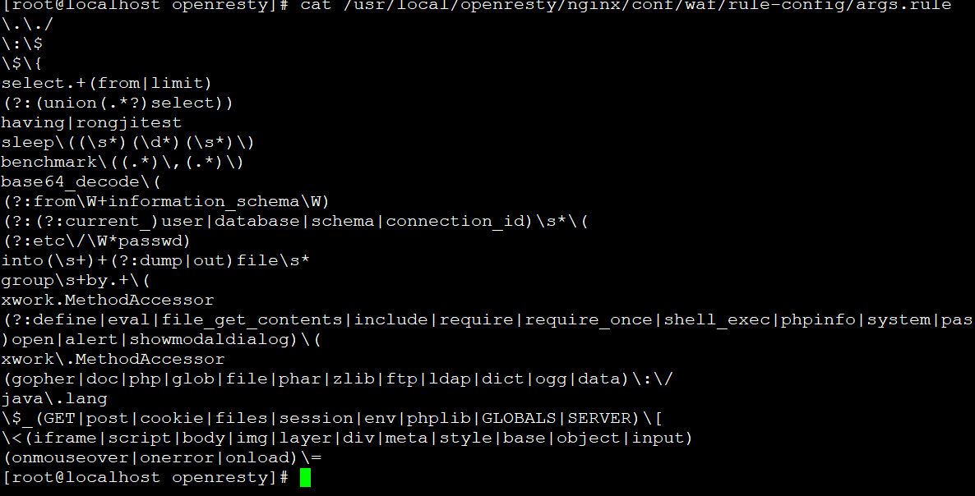
我们进行访问 http://192.168.50.245 /hello?aa=select id from mysql,得到如下，进行匹配:

我们也可以根据自己需求去配置，如下最后添加abcops(无需重启nginx):

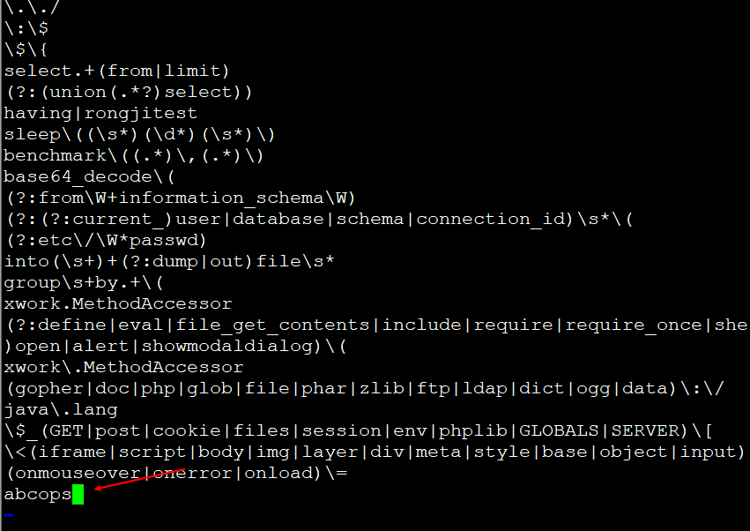
然后我们进行访问: http://192.168.50.245/hello?aa=abcops也会匹配到规则

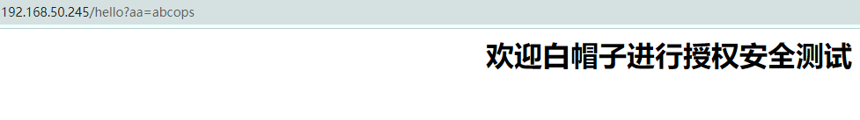
异常POST参数策略配置：需要在config.lua中开启config_post_check = "on"选项。
cat /usr/local/openresty/nginx/conf/waf/rule-config/post.rule
默认POST请求封禁如下，POST封禁内容与GET相似：

\.\./
select.+(from|limit)
(?:(union(.*?)select))
having|rongjitest
sleep\((\s*)(\d*)(\s*)\)
benchmark\((.*)\,(.*)\)
base64_decode\(
(?:from\W+information_schema\W)
(?:(?:current_)user|database|schema|connection_id)\s*\(
(?:etc\/\W*passwd)
into(\s+)+(?:dump|out)file\s*
group\s+by.+\(
xwork.MethodAccessor
(?:define|eval|file_get_contents|include|require|require_once|shell_exec|phpinfo|system|passthru|preg_\w+|execute|echo|print|print_r|var_dump|(fp)open|alert|showmodaldialog)\(
xwork\.MethodAccessor
(gopher|doc|php|glob|file|phar|zlib|ftp|ldap|dict|ogg|data)\:\/
java\.lang
\$_(GET|post|cookie|files|session|env|phplib|GLOBALS|SERVER)\[
\<(iframe|script|body|img|layer|div|meta|style|base|object|input)
(onmouseover|onerror|onload)\=

参考 https://www.cnblogs.com/cheyunhua/p/13395745.html

########## 负载均衡 ########

upstream foo.com {
server 205.185.124.167:80;
server 103.79.79.167:8866;
#server 127.0.0.1:12356 backup;
}
lua_shared_dict healthcheck 1m;

lua_socket_log_errors off;

init_worker_by_lua_block {
local hc = require "resty.upstream.healthcheck"

local ok, err = hc.spawn_checker{
shm = "healthcheck", -- defined by "lua_shared_dict"
upstream = "foo.com", -- defined by "upstream"
type = "http",

http_req = "GET / HTTP/1.0\r\nHost: foo.com\r\n\r\n",
-- raw HTTP request for checking 定义检测页面

interval = 2000, -- run the check cycle every 2 sec 检测间隔时间
timeout = 2000, -- 1 sec is the timeout for network operations 检测超时时间
fall = 3, -- # of successive failures before turning a peer down 失败3次认为down
rise = 2, -- # of successive successes before turning a peer up 成功2次认为up
valid_statuses = {200, 302}, -- a list valid HTTP status code 定义http健康状态码
concurrency = 10, -- concurrency level for test requests
}
if not ok then
ngx.log(ngx.ERR, "failed to spawn health checker: ", err)
return
end

-- Just call hc.spawn_checker() for more times here if you have
-- more upstream groups to monitor. One call for one upstream group.
-- They can all share the same shm zone without conflicts but they
-- need a bigger shm zone for obvious reasons.
}
server
{
listen 80;
server_name 0.0.0.0;
index index.html index.php;
root html;

location / {
proxy_pass http://foo.com;
#root html;
#index index.html index.htm;
}
# status page for all the peers:
location = /status {
access_log off;
#allow 127.0.0.1;
#deny all;

default_type text/plain;
content_by_lua_block {
local hc = require "resty.upstream.healthcheck"
ngx.say("Nginx Worker PID: ", ngx.worker.pid())
ngx.print(hc.status_page())
}
}

location ~ .*\.(gif|jpg|jpeg|png|bmp|swf)$
{
expires 30d;
error_log /dev/null;
access_log /dev/null;
}

location ~ .*\.(js|css)?$
{
expires 12h;
error_log /dev/null;
access_log /dev/null;
}
}

访问状态页：
http://192.168.50.245/status

